Designed By

**Newton BEARS Team #1**

**Brown Middle School**

**Engineering & Robotics**

**Squad (BEARS)**

James: Does your new hearing aid work?

Grandma: No. When a truck rolls by, it makes a loud screeching noise that hurts my ears.

James: Can you lower the sound volume?

Grandma: Yes, I can, but I can’t hear the television or telephone well when I put it low.

James: Oh, I'm so sorry. Do you think a new aid that cuts off high-volume and high-pitch sound would be better?

Grandma: I will try anything…

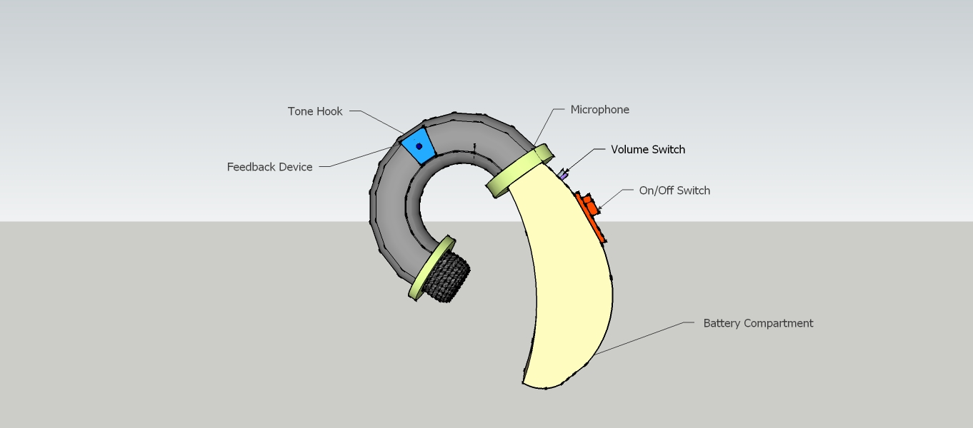

# Our Solution

The small microphone changes the sound to an electronic signal. Then a voltmeter would measure the electronic frequencies. Then that sound can be omitted from being played on the speaker. This means that feedback frequency wouldn't play after the first split second. That would stop the feedback, as the feedback in current hearing aids is being caused by a microphone picking up sound.

Hearing Aids:

Do they Really Work?

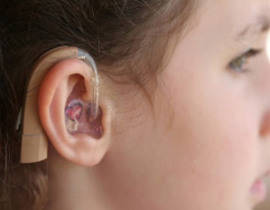

# Our Interview



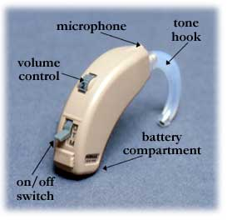



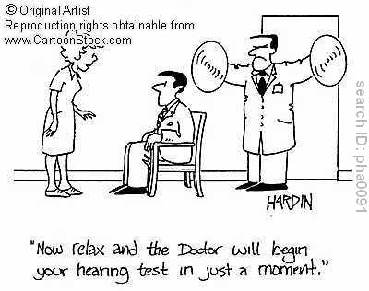



There are many kinds of hearing aids today, from cheap disposable ones to 5,000 dollar high-performance ones. Five different types of hearing aids dominate the market today, one is BTE (Behind-The-Ear) hearing aid. It consists of a large block-like battery compartment which is hidden behind the ear. From the battery compartment, there lies a tube which is connected to the ear piece, which is often crafted from a mold of the person's ear. All hearing aids work in a similar way. A microphone in the battery compartment detects incoming sounds and background noises. It then sends electronic signals to the circuit board, After analyzing the signals and ‘deciding’ what pitch amplifies the hearing, the circuit them emits a beep-like tone, which is carried into the ear, after passing through the sound tube and the ear piece. Currently, there are many problems with hearing aids. Hearing aids are uncomfortable and very heavy. They also can emit distorted or unclear sounds. In addition, many people are very sensitive about what goes into their ears, and feel that hearing aids make them look ugly. However, one of the worst problems with hearing aids is that they give off feedback which is actually debilitating to the ear when using a phone.

# Hearing Aids Today

# Hearing Loss and Aging

According to WebMD, about one-third of Americans between the ages of 65 and 74 have hearing problems. About half the people who are 86 and older have hearing loss. Whether a hearing loss is minor (missing certain sounds) or major (being profoundly deaf), it is a serious concern for our seniors.

Hearing problems can make seniors feel embarrassed, upset and lonely, but wearing an aid also can also feel uncomfortable, embarrassing, and challenging. Some hearing aids afflict headaches.